Big Sky Area Games

Registration Packet
2024

DATE: March 1, 2024
TO: Local Program Coordinators,
(Please provide copies to Coaches as needed)
FROM: Spring Games Planning Team (contact us at kwood.somt@gmail.com)

RE: Big Sky Area Spring Games Registration Packet

The 2024 Big Sky Area Games are scheduled for April 25th and 26th in Belgrade and Bozeman, MT with Opening Ceremonies kicking off at the Belgrade High School Special Events Center on Thursday, April 25th. The “off-site” events will occur throughout the area so please see the schedule below (which is currently tentative).

Each athlete must be registered in their event for the Area Games (this includes unified partners). Enclosed in this packet are:

- Directions to the Belgrade Special Events Center
- Bus Parking Instructions
- Schedule of events (tentative at this time)
- Athlete/Coach/Team Volunteer registration form (separate Excel attachment that includes lunch and t-shirt registration)
- Special Requirements form
- Event names for Area Games (to be used for completing the registration form)

Please fill out all forms.
- Rosters, lunch orders, t-shirt orders, and special requirements forms will be completed and returned to kwood.somt@gmail.com no later than Sunday, March 24th.
- Lunch will only be provided on Thursday. Athletes must provide their own lunch on Friday.
- Final athlete registration form (same form your rosters, lunch orders, and t-shirt orders are on) will be completed and returned to kwood.somt@gmail.com NO LATER THAN Sunday, April 7th.
  - Due to the amount of time it takes to create heat sheets, late registrations will not be accepted.
  - Registration forms must be emailed in Excel format. Please do not send Google Docs or other versions of the form.
  - Athletes may register for up to 3 different sports with a maximum of 2 events in each sport.
  - If an athlete is only registering for Athletics and no other sports, they will be allowed to register for up to 4 events in Athletics.
  - Relays do not count towards a competitor’s event totals.
  - LPC’s and coaches need to be aware of time conflicts when registering athletes and avoid them.

Information specific to Soccer:

- Each unified team must have AT LEAST two unified teammates/partners on their roster. There must be two unified partners on the field of play at all times. No more, no less.
- After final registrations are received on April 7th, LPC’s who have soccer teams competing at Area Spring Games will receive an official roster form to review for their teams.

Information specific to Golf:
- An athlete may compete in either Individual Skills OR Course Play. They cannot sign up for both.

Information specific to Aquatics:

- There will be a coaches meeting at 12:45pm sharp at the Swim Center prior to the 1:00pm start time. All Aquatic coaches need to attend so they are familiar with the flow of the events for the competition.
- Warm up for 25 Meter events and less will run from 1:00pm-1:15pm.
- A 15 minute warm up for 50 Meter, 100 Meter, and relay events will start at the conclusion of the 25 Meter races while the pool set up is being converted.
- No food is allowed in the pool area.

**This registration packet is for the Big Sky Area Games only. The Great Falls state office sends their registration packet separately. The packet for State Games must be completed and returned to Great Falls.

Directions to Belgrade High School Special Events Center:

- Travel on I-90 to Belgrade
- Travel to Jackrabbit Lane:
  - If traveling from Bozeman/Livingston: Take Exit 298 on Jackrabbit Ln & make a right
  - If traveling from Manhattan/Three Forks: Take Exit 298 on Amsterdam Rd then make a Left onto Jackrabbit Ln
- Continue on Jackrabbit to Spooner Road
- Events Center will be on your right: 220 Spooner Road, Belgrade, MT

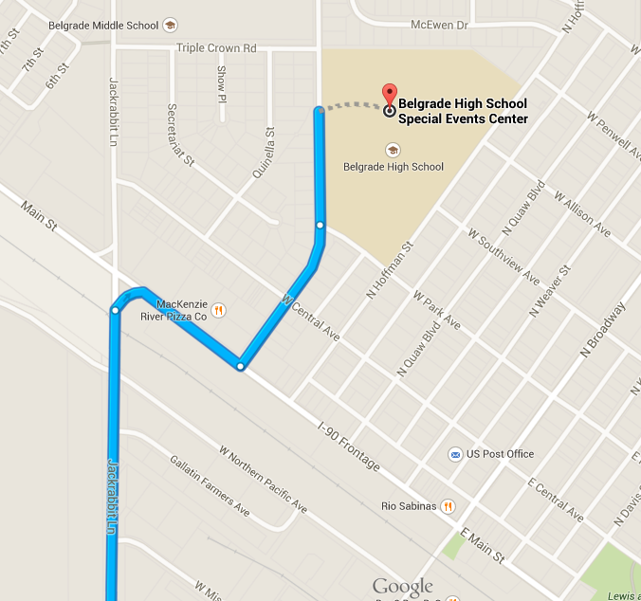
Parking Instructions for Belgrade High School Special Events Center:

- Teams and spectators must avoid parking in spaces that are painted with personalized drawings. These indicate spaces that belong to and are paid for by students.
- Additional parking may be found on the adjacent streets.

Bus Parking Instructions:

Buses can park in the area indicated in red below. Along Spooner Rd in front of the Special Events Center.

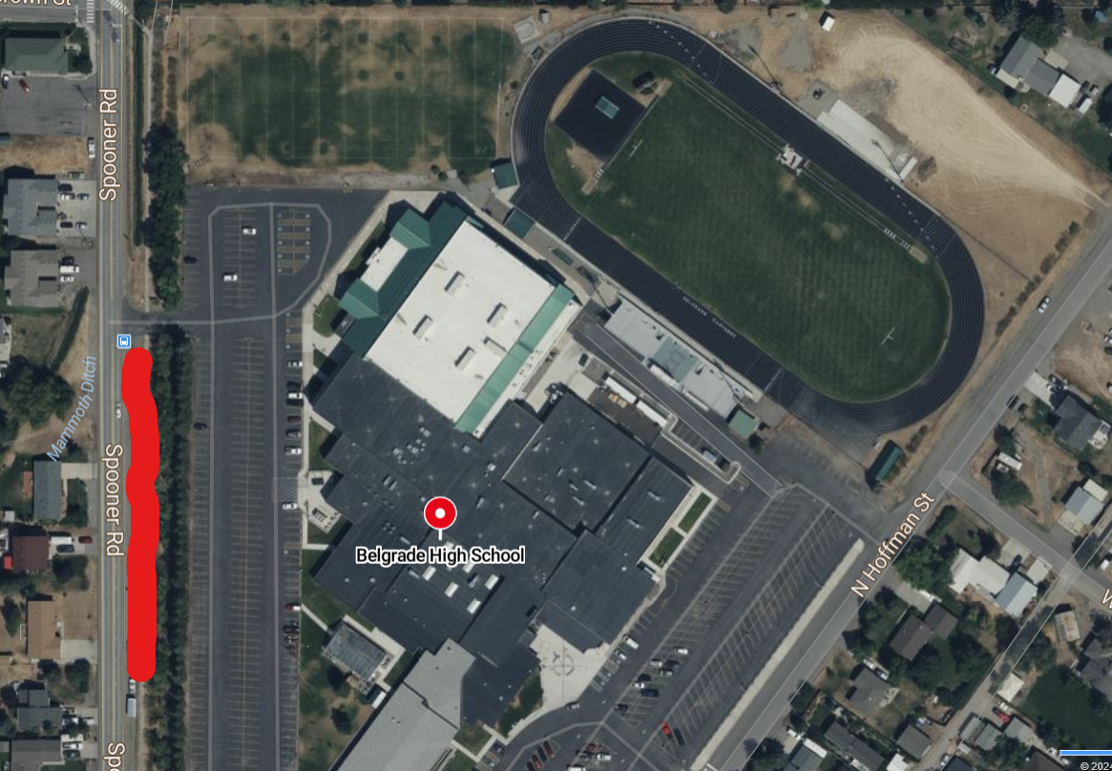

2024 BIG SKY AREA GAMES SCHEDULE
April 25th and 26th
This is currently a tentative schedule.

THURSDAY, APRIL 25, 2024-Belgrade High School, Belgrade, MT

8:30-9:10: Athlete & Team Check-In-Belgrade High School Events Center (220 Spooner Road)

Volunteer Check-In-Belgrade High School Events Center (220 Spooner Road)

All teams and volunteers need to check-in. Teams will be escorted to the staging area for Opening Ceremonies

9:30-10:00: OPENING CEREMONIES-Gym

10:45-2:30: TRACK/ATHLETICS RUNNING & WALKING-Outdoor Track (there will be a break for lunch around noon)

1500 M Run-maximum time to qualify-12 minutes
25M Dash
25M Walk
50m Dash
50M Walk
100M Dash
100M Walk
200M Run
200M Walk
400M Run
400M Walk
800M Run-maximum time to qualify-6 minutes
800M Walk-maximum time to qualify-9 minutes
4x100M Relay
4x100M Unified Relay
4x400M Relay
4x400M Unified Relay

11:00-12:30 JUMPS-Outdoor Track
Standing Long Jump
Running Long Jump

11:00-11:30: ASSISTED WALKING-Gym
10M
25M

11:30-12:00: WHEELCHAIR EVENTS-Gym
10M Manual Wheelchair
25M Manual Wheelchair
30M Manual Slalom
30M Motorized Slalom
50M Motorized Slalom
25M Motorized Obstacle

11:45-12:00: LUNCH PICK UP-Teams to pick up their box of lunches in the concession area of the Special Events Center.

12:30-2:30: THROWING EVENTS-Outdoor Track
Softball throw (M followed by F)
Wheelchair Softball Throw (M followed by F)
Shotput (M followed by F)
Wheelchair Shotput (M followed by F)
Turbo Jav (M followed by F)

12:30-2:30: BOCCE-Outdoor Practice Field

2:30-2:45: PRESENTATION OF SPIRIT AWARD-Gym

FRIDAY, APRIL 26, 2024-MISC LOCATIONS, BOZEMAN, MT

8:30-2:30: SOCCER-TBD

9:00-11:00: GOLF-Cottonwood Golf Course-8955 River Road

9:00-11:00: CYCLING-Grace Bible Church-3625 S 19th Ave

1:00-3:30: AQUATICS-Bozeman Swim Center-1211 W Main St. (There will be a coach’s meeting at 12:45 with the Venue Director).

NAME OF TEAM / ORGANIZATION: _______________________________________

Special Requirements Form

If your team (or any individual on your team) has any special requirements, please list them here. For example, if you have an Autistic athlete who would focus and perform his/her best if scheduled in an early heat, list that here. Another example would be if you have an athlete who should not be photographed.

________________________________________________________________________
________________________________________________________________________
________________________________________________________________________
________________________________________________________________________
________________________________________________________________________
________________________________________________________________________
________________________________________________________________________
________________________________________________________________________
________________________________________________________________________
________________________________________________________________________
________________________________________________________________________
________________________________________________________________________
________________________________________________________________________

Please return this form no later than March 24th if you have special requirements.
You can email this form to kwood.somt@gmail.com
AREA GAMES EVENTS - 2024

AQUATICS
10 Meter Assisted Swim – with kickboard
10 Meter Assisted Swim
15 Meter Aquatic Walk
15 Meter Flotation Race
15 Meter Unassisted Swim
25 Meter Backstroke
25 Meter Breaststroke
25 Meter Butterfly
25 Meter Flotation Race
25 Meter Freestyle
50 Meter Backstroke
50 Meter Breaststroke
50 Meter Butterfly
50 Meter Freestyle
100 Meter Backstroke
100 Meter Breaststroke
100 Meter Freestyle
200 Meter Freestyle
400 Meter Freestyle
4 x 25 Meter Freestyle Relay
4 x 25 Meter Freestyle Unified Relay
4 x 50 Meter Freestyle Relay
4 x 50 Meter Freestyle Unified Relay
ATHLETICS
10 Meter Manual Wheelchair Race
25 Meter Manual Wheelchair Race
25 Meter Motorized Wheelchair Obstacle Course
30 Meter Manual Wheelchair Slalom Race
30 Meter Motorized Wheelchair Slalom Race
50 Meter Motorized Wheelchair Slalom Race
10 Meter Assisted Walk
25 Meter Assisted Walk
25 Meter Walk
50 Meter Walk
100 Meter Walk
200 Meter Walk
400 Meter Walk
800 Meter Walk – maximum time to qualify-9 minutes
25 Meter Dash
50 Meter Dash
100 Meter Dash
200 Meter Run
400 Meter Run
800 Meter Run – maximum time to qualify-6 minutes
1500 Meter Run – maximum time to qualify-12 minutes
4 x 100 Meter Relay
4 x 100 Meter Unified Relay
4 x 400 Meter Relay
4 x 400 Meter Unified Relay
Standing Long Jump
Running Long Jump
Softball Throw
Wheelchair Softball Throw - Men
Wheelchair Softball Throw - Women
Shot put – Men
Shot put – Women
Wheelchair Shot put – Men
Wheelchair Shot put - Women
Turbo Javelin
BOCCE
Bocce Doubles
Bocce Doubles Unified
CYCLING (please designate 2 wheel or 3 wheel on registration form)
500 Meter Time Trial – 2 WHEEL
500 Meter Time Trial – 3 WHEEL
1 Kilometer Time Trial – 2 WHEEL
1 Kilometer Time Trial – 3 WHEEL
GOLF
Level 1: Individual Skills Competition
Level 2: Unified Alternate Shot Team Play Competition – 9 hole
Level 4: Individual Stroke Play Competition – 9 hole
SOCCER
5-a-side Traditional Team
5-a-side Unified Team

